Digital Literacy
for Kindergarten

An Introductory Guide
for BC Kindergarten Teachers
Created by Tracey Westwood

This work is licensed under a
Creative Commons Attribution-NonCommercial 4.0 International License.

Table of Contents
About This Guide 3
The iPad and the iPad Camera 5
The Draw and Tell App and Creative Work 12
The Internet 18
Online Safety Wheel 22
Illustrated Online Safety Wheel 23
Social Media 24
Google and Key Word Searching 28
Clicking Carefully 32
YouTube and Autoplay 35
Balancing Your Time 40
Balancing Activities 45
Goodbye Technology 46
Don’t Believe Everything You See 47
Fake News 51
Keeping Private Information Private (3 parts) 52
Part 1: Secrets 52
Part 2: Usernames 55
Part 3: Passwords 57
QWERTY Keyboard 60
I Made a New Password 61
Digital Footprints: Protecting Your Private Info (2 Parts) 62
Part 1: Introduction and Tool 62
Part 2: Quiz 65
Digital Footprints OK 68
Digital Footprints NO 68
Email 70
Coding (3 parts) 73
Part 1: How to Wash Your Hands 74
Part 2: My Robot Friend 75
Part 3: Programmable Robots 77
Coding Game Cards 80

About This Guide

Is it appropriate to begin using Information and Communications Technology (ICT) with young learners? The debate over the potential benefits and detriments of using ICT has yet to be truly resolved, but the Province of British Columbia’s Ministry of Education has taken a stand and added digital literacy to the curriculum. In addition, the Ministry has adopted B.C.’s Digital Literacy Framework to guide the scaffolding of skills for all children in the kindergarten to grade 12 school system. Individual educators have responded to the curriculum changes with varying levels of enthusiasm. Many educators struggle with their own digital literacy skills and others just need a bit of guidance. This guide was created to help kindergarten educators get started teaching digital literacy skills.
This guide contains lessons that, as a unit, cover the introduction of all the concepts in B.C.’s Digital Literacy Framework that apply to kindergarten. The lessons included in this guide are presented in an order that allows the educator to introduce concepts one after the other, but do not necessarily need to be consecutive. It is recommended that educators introduce concepts alongside their regular lessons. For example, teaching about being kind online would be a good companion to social learning lessons about being kind to others in person. Lessons about targeted advertising go well with critical thinking lessons about wants and needs. In addition to being well suited to several non-digital companion lessons, learning about iPad’s camera app and the Draw and Tell app could go anywhere in the line-up but they are fun and useful apps to use all year. Also, the internet and social media lessons would be introduced early on as the educator starts using the internet and social media with the class.
Each lesson is preceded by a table outlining the corresponding big ideas, curricular competencies, and content from B.C.’s Curriculum, as well as corresponding concepts in B.C.’s Digital Literacy Framework. The lessons are scripted to make them as simple as possible, but of course, individuals can adapt them for their own comfort level and teaching style, as well as the unique capabilities of the class. Many of the lessons ask the educator to “pre-search” for things. When using a search engine such as Google, one never knows what will turn up on the screen, so educators are encouraged to conduct internet searches in advance of the actual lessons to ensure there are no unpleasant surprises when demonstrating searches in front of children. Each lesson has a yellow box at the end with ideas for extensions or companion lessons.
Few of the introductory lessons in this guide actually give the learners hands-on experience with technology. Putting the technology in the hands of the learners is the decision of each educator. However, applying the knowledge they have gained in these introductions is key to making them a regular part of their ICT habits. Incorporating ICT into learners’ broader explorations can enhance their learning if done in a thoughtful and safely guided manner. Consider making iPads a measured part of play centres by allowing pairs to explore educational games or guiding learners as they research their own inquiries. Allow students to use the camera and video apps to document their own learning, share their own stories, and share their creations with a broader audience. Use the motivating power of apps like Draw and Tell to foster creativity and persistence, as well as practice numeracy and literacy concepts. Finally, give up the notion of one-to-one iPads. Two or three children on a single device encourages social interaction and peer tutoring, as well as practicing saying, “Goodbye Technology” with the end of each turn.

The iPad and the iPad Camera

Big Ideas
- Skills can be developed through play.
- Technologies are tools that extend human capabilities.
BC Curricular Competencies  - Decide on how and with whom to share their product.  - Use materials, tools, and technologies in a safe manner in both physical and digital environments.  - Develop their skills and add new ones through play and collaborative work.  - Explore the use of simple, available tools and technologies to extend their capabilities. | BC Curricular Content  - Students are expected to use the learning standards for Curricular Competencies from Applied Design, Skills, and Technologies K-3 in combination with grade-level content from other areas of learning in cross-curricular activities to develop foundational mindsets and skills in design thinking and making. | BC Digital Literacy Framework  - The student understands that computer programming algorithms are sets of instructions that tell computers what to do.  - The student can use a digital device, which may be one of many types (e.g., Desktop PC, Laptop, Tablet, Smartphone).

Students will be introduced to the Apple iPad and be asked to take photographs around the classroom. Students will share and reflect on their photos, learning about asking permission.

This activity is approximately 55-60 minutes.

Materials needed:  - class set of iPads, one per pair (ideally)  Optional:  - digital projector  - document camera connected to a projector or  dongle to connect the iPad to the projector. | Demonstration works best if you hold the iPad under the document camera so the students can see where you place your fingers, how you press the app and Home buttons, and where the camera lens is.

Activity | Time | Teacher | Learners | Observe/Assess
Engage | 5 min. | As a whole class, show the iPad and ask,  - What do you think you know about this device?  Allow for responses  - This is called an iPad. It is a tablet that uses computer or what we call digital technology to help people do things.  - How many of you have used one before? What activities do you use it for?  - When you use a tablet at home, you may use it as a tool for entertainment or communication like... (examples from the class). Here at school, we use it as a tool for learning, not a toy. | Engage in group discussion | Listens  Participates  Shares ideas
Demonstrate | 5 min. | Speak your thinking aloud as you model each step.  - Our school iPads are in these sturdy cases to help protect them, but they are still quite fragile, so you need to be careful, hold them by the handle or with two hands. Please do not swing them about. Don’t put anything on top of them and they need to stay away from water. Let’s make sure all our water bottles are on the shelf.  - Our school iPads are always in stand-by mode so when you want to get started you need to press this button here, the Home button.  Press the Home button.  - The Home button will bring you back to this page. See, these little squares are the apps. The word, Apps, is short for applications. These activate codes that tell the iPad what to do.  - Those of you who have used apps before, what kind of apps are on your tablet?  Responses  - Today we’re going to look at two apps. This one with the camera is where we go when we want to take pictures or video.  Press the camera button and show the children what they see on the screen. Point out the camera lenses on the back and front of the iPad.  - I want to take a picture of Suzy. Who does Suzy’s body belong to? Should I ask Suzy for permission to take a picture of her.  Ask Suzy permission. Whisper to Suzy to say no.  - Oh, Suzy says, no, but I really want a picture of Suzy. Should I be sneaky and take one anyway?  - No, of course not. I’ll have to find another friend to take a picture of. Bobby, can I take your picture?  - Bobby says, yes, so I’m going to point my camera and press the white shutter button. If your button is red, your camera is in the wrong setting and you need to come see me.  Point out the white shutter button and turn the iPad and Bobby around (with his back to the wall) so the class can see you press it and what happens when you do.  - Now I look at the photo. I use this little image under the white shutter button. Is it a good one? I think so. Should I show Bobby and ask if he approves? Yes, I should. Bobby, is this photo okay?  Whisper to Bobby to say no.  - Uh oh, Bobby doesn’t like it. What should I do now?  Listen to their responses. Someone will say take another one.  - I agree, I should take another one, but Bobby doesn’t want me to keep this one so I need to delete it. Delete means send it to the trash so I don’t have it anymore. To send it to the trash, we use this little trash can icon. Bobby, I deleted that photo. Can I take another? |  | Listens  Participates  Shares ideas  Listens  Participates  Shares ideas
Review Instructions | 1 min. | - Who wants to show me what buttons to push to take the photo?  Put the iPad back under the doc camera and talk through the instructions as the student is pointing to the big screen. | Volunteer to demonstrate
Explore | 10-15 min. | Hand out iPads and let them go. Monitor the room and trouble-shoot as needed. Take note of photos that have extra people or student work showing in the background.  - You have 10 minutes to take some pictures. Don’t forget to ask permission. | Take as many photos as they like, exploring with the camera | On task  Respectful use of equipment  Asks permission of main subject
Regroup and reflect  Learn photos app | 10 min. | Regroup to talk about photos.  - blurry photos  - extra people in photos  - intellectual property in photos  - intentional “photo bombing” implies consent  Ask students to put their iPads face down in front of them and hands folded.  - Now we want to look at our pictures. We need to use this app here. This is the photos or gallery app.  Press and show students how to navigate to their recent photos.  - Who wants to share a photo with the class? Suzy has a photo. Who is in your photo, Suzy?  - When you asked Jill about taking her picture, did you ask if you could show it to other people or does she think it’s just for you?  - Is that right, Jill? If you didn’t say you were going to show it to others, then you have to ask again. Jill, is it okay with you if we look at your photo?  Look at the photo and comment.  Choose another volunteer, this time one you noticed that has extra people or work in the background. Go through permissions again. Put up the photo.  - Uh oh, who/what is that in the back of the photo? Did you ask their permission to take and show the picture? Everyone take a look at your pictures and see if you have photos with extras in the background.  - What can we do?  - Yes, we can ask their permission. Yes, we can delete them and take another. | Engage in group conversation  Volunteer to share  Watch and listen | Listens  Participates  Shares ideas  Watches Listens
Explore | 10 min. | Review and set them off again. Monitor the room. Check around and ask them questions about their photos.  - Let’s try some more. This time pay attention to what is behind your subject and don’t forget to ask permission, even if it’s someone’s work. | Take as many photos as they like, exploring with the camera | On task  Respectful use of equipment  Asks permission
Regroup and reflect | 3 min. | Regroup  - If you have permission to share a photo with others, share with an elbow buddy (someone beside you). | Share and discuss photos | On task  Respectful use of equipment
Preparing iPads for charging | 10 min. | - Were just about done for today. At school, we make sure all the photos are deleted before we put our iPads away.  Model aloud:  - finding photos is the photo/gallery app  - deleting using the trash can or using the select tool if there are many  - show empty photo album  Let students delete all the photos and show you the empty album. Help as needed.  - Next, we need to close all the apps we used.  Model aloud:  - double click to reveal all the open apps  - sweep up to close the app  - show what happens when we double click but the apps are all closed  Double clicking is tricky for little fingers. You can make it easier by changing the accessibility settings for your iPads.  Settings > General > Accessibility > Home Button > Slowest  Let students close all the apps.  - Now I can check that you closed all the apps and put the iPads back in the charging box.  Model aloud how you will:  - locate the charging port and insert the cable  - slide the iPad into the charging box  - put the rest away later or as you listen. | Listen  Delete all photos  Close all apps | Listens  On task  Successfully follows directions  Seeks help from peers or adults when needed.
Recap | 2 min. | - Tell me what you learned about taking photos with a digital device like the iPad. | Engage in group discussion | Listens  Participates  Shares ideas

In the following weeks…
- Allow your special helper to take photos during play time.
- Extend this lesson to individuals or small groups by introducing the video option. Invite students to record each other performing plays or making their own music video.

The concepts in this activity connect well with:
- Body Science - Teach children that there are certain body parts (i.e., breasts, bottom, lips, and sexual anatomy) that are only allowed to be touched or viewed by a trusted adult like a parent (or doctor) to help with washing or when hurt. Children are permitted to view or touch themselves because their bodies belong to them.
- Hug Not Mug - Teach that only “you” can give someone permission to hug you. If someone wants a hug, they must invite you with a verbal invitation and/or outstretched arms. Hugging without an invitation is defined as a “mugging.”
- That’s Mine - Teach students that any object, toy, or piece of art they find at school is the property of another person until otherwise explicitly indicated. For example, if they find a drawing (intellectual property) on the floor, they must make every effort to find its owner/creator. “Finders keepers” is not a valid argument for ownership. If they want to ask the owner if they can keep it that is allowed but “the deal” must be witnessed by an adult. Children can choose to put items in the recycling bin or the open sharing space, available for taking. Items from home such as toys must be accompanied by parent letter before being approved as an open sharing or trade item.
More:
- You can retrieve photos that were accidentally deleted or permanently delete photos by going into the Photos app > Albums > Recently Deleted. It’s a good idea to empty this folder regularly.

The Draw and Tell App and Creative Work

Big Ideas
- Designs grow out of natural curiosity.
- Skills can be developed through play.
- Technologies are tools that extend human capabilities.
- People create art to express who they are as individuals and community.
- People connect to others and share ideas through the arts.
BC Curricular Competencies  - Generate ideas from their experiences and interests.  - Add to others’ ideas.  - Choose an idea to pursue.  - Make a product using known procedures or through modelling of others  - Use trial and error to make changes, solve problems, or incorporate new ideas from self and others.  - Tell the story of designing and making their product  - Use materials, tools, and technologies in a safe manner in both physical and digital environments.  - Develop their skills and add new ones through play and collaborative work.  - Explore the use of simple, available tools and technologies to extend their capabilities. | BC Curricular Content  - Students are expected to use the learning standards for Curricular Competencies from Applied Design, Skills, and Technologies K-3 in combination with grade-level content from other areas of learning in cross-curricular activities to develop foundational mindsets and skills in design thinking and making. | BC Digital Literacy Framework  - The student understands that computer programming algorithms are sets of instructions that tell computers what to do.  - The student can use a digital device, which may be one of many types (e.g., Desktop PC, Laptop, Tablet, Smartphone).  - The student uses a variety of digital media (text, audio, and movie) to express themselves creatively.  - The student understands the concept of having ownership over creative work.

Learners will explore the Draw and Tell app. They will use it to create an original creature. They will discuss original ideas, attribution of others’ ideas, and copying versus inspiration.

This activity is approximately 50 minutes.

Materials needed:
- class set of iPads, one per pair (ideally), or group
- iPads must have the free app, Draw and Tell (by Duck Duck Moose)
or a comparable app downloaded.

Optional:
- digital projector
- document camera connected to a projector or dongle to connect the iPad to the projector.

Activity | Time | Teacher | Learners | Observe/Assess
Engage | 5 min. | - Hands up if you like to draw. Why? Why not?  - Why do we draw? (To express our ideas)  - We’re going to do some drawing today using the iPads.  - Where do your ideas come from? (my brain, books, movies, friends)  - What if I drew a really great dog on a piece of paper but I dropped it? Then you come along and pick it up off the floor. Is it okay for you to keep it? Or tell people you drew it?  - No, because we already know that “Finders Keepers” is not a friendly rule. What if I drew it on the iPad?  Draw it, or whatever, on the iPad as you hold it under the doc cam.  - You really like it. Is it okay for you to copy it?  - Should you ask me first?  - Can you copy it and say that it was your idea? No, you need to give me, the creator, I created it, credit for my idea. Credit is when you make sure everyone knows where an idea came from. We also have another fancy word, attribution. If I want to show someone’s work to someone else, I have to give the creator the credit. I have to attribute the work to the creator.  - So, here’s my dog. You like it but you don’t want to copy it, you want to make your own dog. Can you use my idea for the eyes? Sure, you can. Can you use my ideas for the tail? I think you can. If you use my eyes and my tail ideas but then draw them a little bit differently, is that copying? No. It looks like maybe you were inspired by my ideas, but you made your own original work. | Engage in group discussion | Listens  Participates  Shares ideas
Demonstrate the activity on the projector  This works best if you position the iPad under the document camera so students can see where to place fingers, how to press the app and Home buttons, and where the camera lens is | 5 min. | - Would you like to make your own drawing on the iPad now?  Drawing can be on open topic or current classroom theme (i.e., Monsters at Halloween).  - Today we’re going to learn how to use the Draw and Tell app. Remember, an app is a bunch of instructions in computer language called code that tell the computer, the tablet, what to do. The code in the camera app that we used before is different than the code in today’s app, so it doesn’t take pictures; it does something else.  Talk aloud as you use the doc camera to model:  - how to turn on the iPad  - identify and press the Draw and Tell app button  - how to turn off the sound effects  - choose background paper  - choose and adjust drawing tools and colours  - use the eraser tool  - use the undo button  Point out the stickers, stencils, and microphone buttons. To save time, you may wish to tell the class to do two drawings without these first and explore the extras afterward.  - When you’re finished your drawing, press this back arrow and it will save your drawing. Then do one more. You can do some exploring in the app after you have saved two drawings. Questions? | Watch and listen | Watches  Listens
Review instructions | 1 min. | - Who can show me where the Draw and Tell app is?  - Who can tell me how we take care of our digital tools? (Carry with two hands, don’t swing them around, keep them away from water bottles, and if something doesn’t seem to be working properly, ask for help)  - What’s your job right now, before anything else? (Create two drawings and save them) | Engage in group discussion | Listens  Participates  Shares ideas
Explore | 20 min. | Hand out iPads and let them go. Monitor the room and trouble-shoot as needed. If possible, create your own drawing borrowing ideas from one or two of the students’ drawings.  - You have about 15 minutes to make some drawings. Don’t forget, if you borrow someone else’s ideas, you need to tell us who. | Create two drawings and then explore the app as they like  May work alone or in groups | On task  Respectful use of equipment  Asks permission of main subject
Regroup | 3 min. | Regroup  - When I say go, everyone look at your two drawings. Choose the one you think is the best one to share with your audience. Your classmates and I are your audience. When you are choosing to show your work, you need to think about what we will think. Which one do you think we will like the best? When I say go, open your choice on your screen and place it at your spot on the tables. We are going to have a gallery walk.  - Who can show us where to find our image gallery? (back arrow)  - GO.  Help students find drawings. | Listen  Choose their best drawing and put it on table | Listens  On task  Self-regulated during transition
Gallery walk | 3 min. | Look at drawings with students. Note any with similarities. | Look at and talk about drawings | On task  Self-regulated
Regroup | 5 min. | - Well done, everyone. I made a drawing too. Model describing my thinking about my drawing and giving credit to students I borrowed ideas from.  - I really liked how ___ made the ____ so I did mine the same, but I did the _____ and _____ differently.  - Anyone use any ideas from other people you want to give credit or attribution for?  If they don’t volunteer,  - I noticed these two had similarities. Did someone borrow ideas here? Did you ask permission? | Raise hands to share credit  Engage in discussion | Listens  Participates  Shares ideas
Preparing iPads for charging | 5 min. | - Time to pack up. Remember, we need to close the app we used.  Model aloud:  - double click to reveal all the open apps  - sweep up to close the app  - show what happens when we double click but the apps are all closed  Double clicking is tricky for little fingers. You can make it easier by changing the accessibility settings for your iPads.  Settings > General > Accessibility > Home Button > Slowest  Let students close all the apps.  - Now I can check that you closed all the apps and put the iPads back in the charging box. | Watch and listen  Close all apps | Watches  Listens  On task  Successfully follows directions  Seeks help from peers or adults when needed
Recap | 2 min. | - Tell me what you learned about drawing pictures with a digital device like the iPad.  - What did we learn about giving credit? | Engage in group discussion | Listens  Participates  Shares ideas

In the following weeks…
- Try Draw and Tell for math activities, using the stickers
- Try it for storytelling, moving the stickers and talking using the microphone

The concepts in this lesson connect well with:
- That’s Mine - Teach students that any object, toy, or piece of art they find at school is the property of another person until otherwise explicitly indicated. For example, if they find a drawing (intellectual property) on the floor, they must make every effort to find its owner/creator. “Finders keepers” is not a valid argument for ownership. If they want to ask the owner if they can keep it that is allowed but “the deal” must be witnessed by an adult. Children can choose to put items in the recycling bin or the open sharing space, available for taking. Items from home such as toys must be accompanied by parent letter before being approved as an open sharing or trade item.

The Internet

Big Ideas
• Technologies are tools that extend human capabilities
• Everything we learn helps us to develop skills.
• Through listening and speaking, we connect with others and share our world.
BC Curricular Competencies  • Use materials, tools, and technologies in a safe manner in both physical and digital environments.  • Work respectfully and constructively with others to achieve common goals.  • Use sources of information and prior knowledge to make meaning.  • Use developmentally appropriate reading, listening, and viewing strategies to make meaning.  • Identify and describe a variety of unsafe and/or uncomfortable situations. | BC Curricular Content  • oral language strategies  • know hazards and potentially unsafe situations | BC Digital Literacy Framework  - The student understands that they can go to exciting places online but needs to follow certain rules to remain safe.  - The student is aware that many websites ask for information that is private and knows how to responsibly handle such requests.

Students will watch several videos and use them to identify 5 rules for saying safe online.

This activity is approximately 20 - 45 minutes.

Materials needed:
- Tablet, smartphone, or computer, connected to the internet, connected to projector
- Large space to draw a web for all to see
- Online Safety Wheel

Prep:
- Pre-search online videos

1. My Online Neighbourhood – Commonsense.org

2. 5 Internet Safety Tips for Kids – Commonsense.org

3. Cyber Five - video and quiz - ABCYa

4. Be Safe Online – OneMoreSong

Activity | Time | Teacher | Learners | Observe/Assess
Engage | 5 min. | - Who can tell me something about the internet, or some people call it The Net or The Web?  - To be on the internet safely, we need to have some rules to follow. What are some rules you have at home about using the internet?  Many children at this age may not be permitted to use digital devices at home at all. It is important that they know their parents are trying to keep them extra safe and they can keep these rules in their pocket for when they are allowed to go online at home or when they go on digital devices at school.  Sort their answers into the Online Safety Wheel drawn or projected on the board or chart paper. If possible, include a simple illustration for each idea. You don’t have to tell students about the titles of the sections until the end.  Sections on wheel include:  1. Private information (like passwords, name, school, address, phone number)  2. Safe places (Only go to places that are just right for you, where a grown up says it’s okay)  3. Safe people (interact with family and friends but not with strangers)  4. Tell an adult (when you find something seems, mean, creepy, or unsafe)  5. Click carefully (Don’t upload or download anything without asking a grownup) | Engage in group discussion | Listens  Participates  Shares ideas
Show video on projector | 15 min. | - Let’s watch this short video and see if there’s any other rules we can add to our web.  Play, My Online Neighbourhood (3:16)  Discuss and add to the wheel  - Let’s watch this super short video and see if there is anything the same or anything different to add.  Play 5 Internet Safety Tips for Kids (0:43)  Discuss and add to the wheel  - This one is the story of two friends playing on the computer together after school. There’s a quiz at the end so watch and listen.  Play Cyber Five (4:37)  Do the short quiz together.  Discuss anything new and add to your wheel  Now review all the rules on your wheel and discuss how they all make the 5 rules needed to be safe online. | Watch and listen  Engage in group discussion | Watches  Listens  Listens  Participates  Shares ideas
Optional  Drawing activity | 20 min. | Draw some examples to illustrate a rule for each section of the Online Safety Wheel. Make copies of the Online Safety Wheel and have students draw a picture for each rule. | Draw a picture  for each rule
Recap | 2 min. | - We learned a lot about online safety today. Does anyone have any questions?  - Let’s wrap this up with a catchy song. Dance time!  Play Be Safe Online – One More Song (2:58) | Engage in group discussion | Listens  Participates  Shares ideas

In the following weeks…
- Post the Illustrated Online Safety Wheel, or a version of your own, in the classroom where you can refer to it.
- Send a copy of the Illustrated Online Safety Wheel home for consistent messaging.
- Anytime you go online with the class or individuals, talk aloud about what you are being careful about.
- Ask students if they went online yesterday and where did they go, what did they do, and did they remember to follow the 5 rules.
- In the Spring term, revisit the topic of internet safety with this video and quiz from BrainPOP Jr.

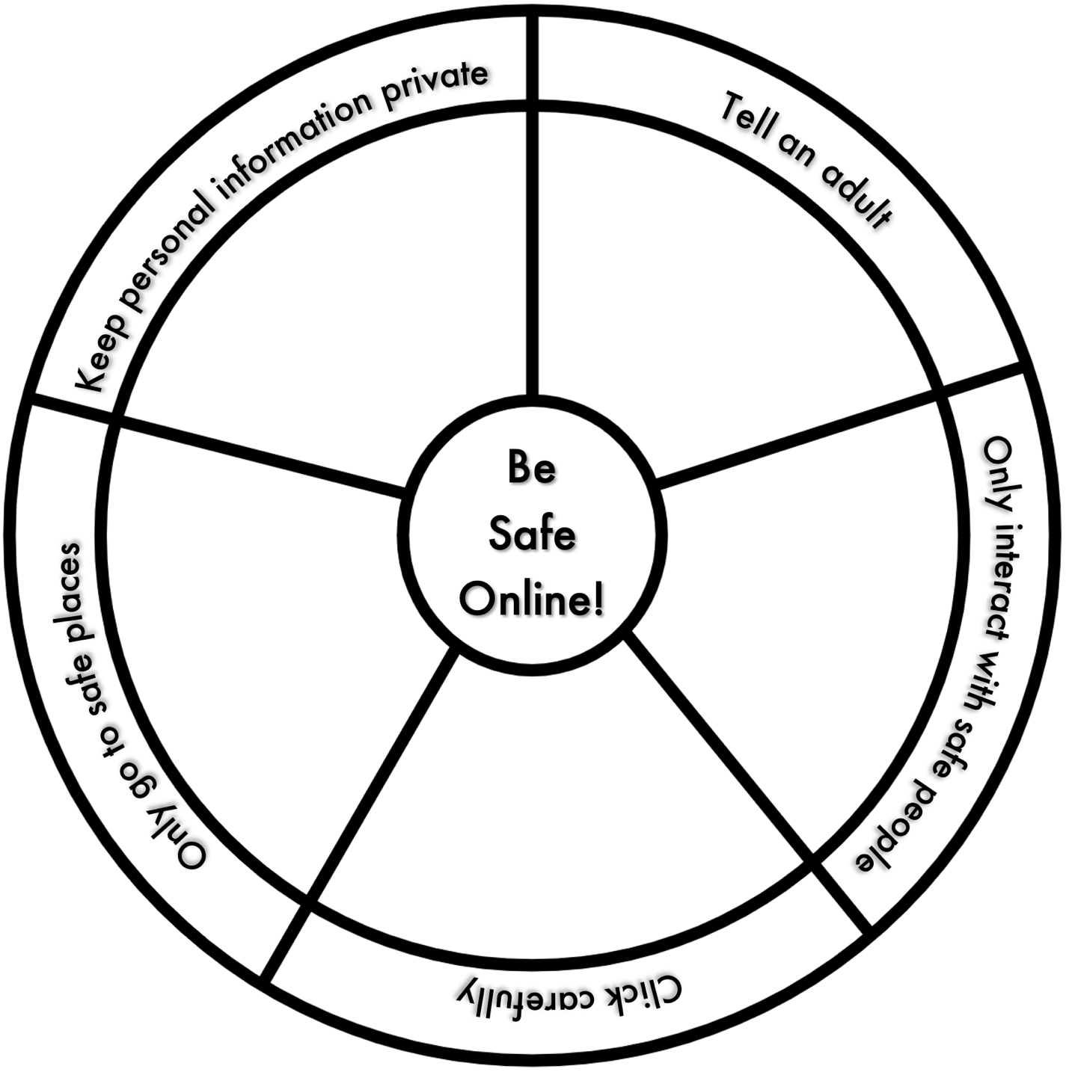
This work by T. Westwood is licensed under a Creative Commons Attribution-NonCommercial 4.0 International License.

1. Private information (like passwords, name, school, address, phone number)
2. Safe places (Only go to places that are just right for you, where a grown up says it’s okay)
3. Safe people (interact with family and friends but not with strangers)
4. Tell an adult (when you find something seems, mean, creepy, or unsafe)
5. Click carefully (Don’t upload or download anything without asking a grownup)

Online Safety Wheel

Illustrated Online Safety Wheel
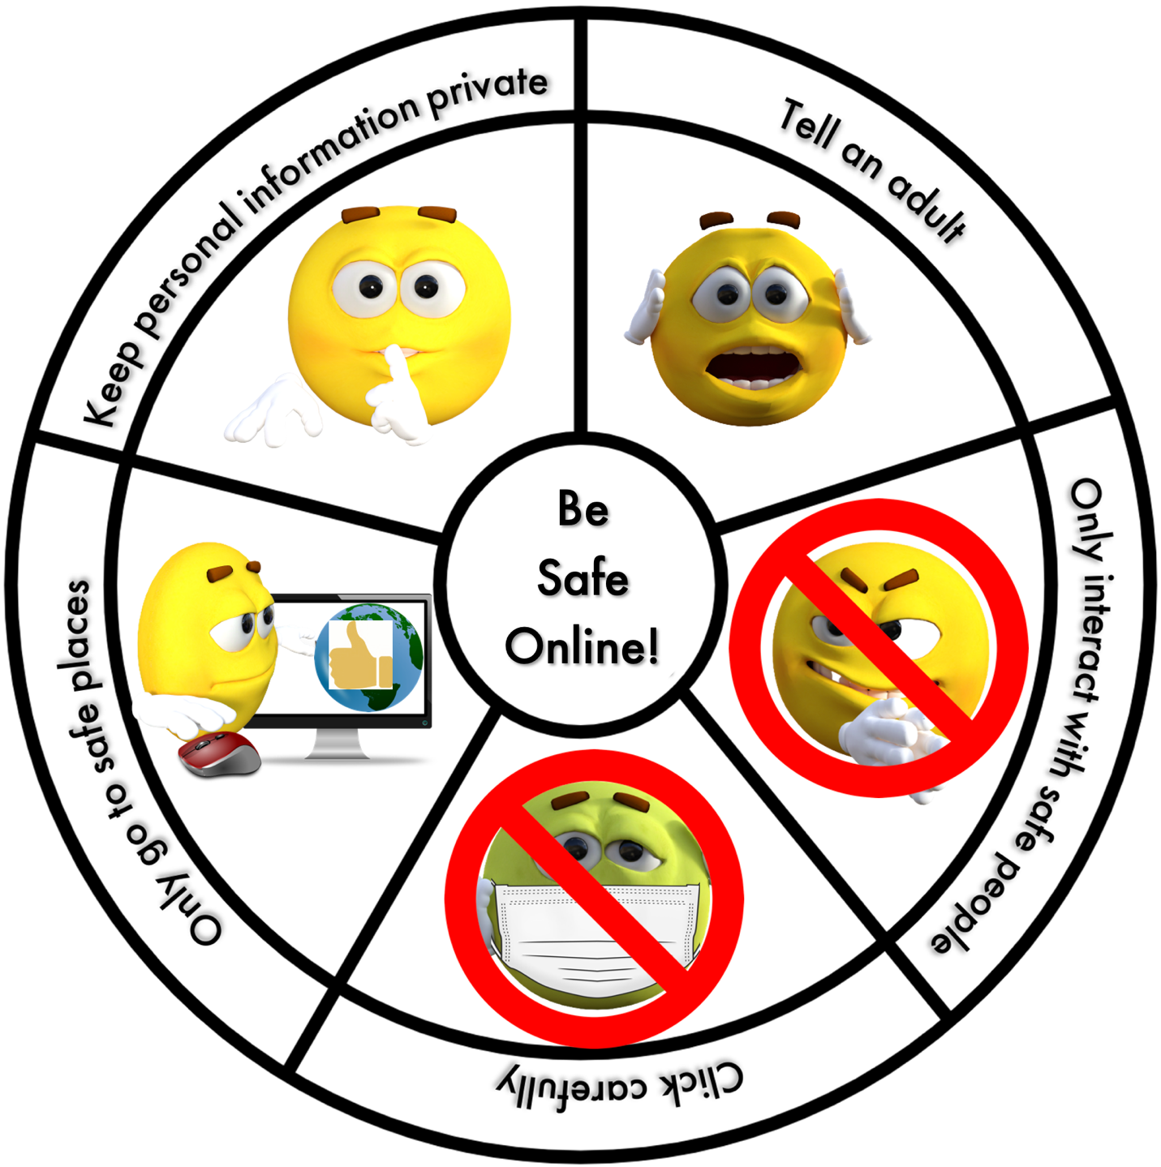
This work by T. Westwood is licensed under a Creative Commons Attribution-NonCommercial 4.0 International License.

Images by
The Digital Artist and Sergei Tokmakov
1. Private information (like passwords, name, school, address, phone number)
2. Safe places (Only go to places that are just right for you, where a grown up says it’s okay)
3. Safe people (interact with family and friends but not with strangers)
4. Tell an adult (when you find something seems, mean, creepy, or unsafe)
5. Click carefully (Don’t upload or download anything without asking a grownup)

Social Media

Big Ideas
- Technologies are tools that extend human capabilities.
- Stories and other texts can be shared through pictures and words.
- Strong communities are the result of being connected to family and community and working together toward common goals.
BC Curricular Competencies  - Decide on how and with whom to share their product  - Demonstrate their product, tell the story of designing and making their product, and explain how their product contributes to the individual, family, community, and/or environment  - Use materials, tools, and technologies in a safe manner in both physical and digital environments  - Explore the use of simple, available tools and technologies to extend their capabilities.  - Engage actively as listeners, viewers, and readers, as appropriate, to develop understanding of self, identity, and community.  - Exchange ideas and perspectives to build shared understanding.  - Use language to identify, create, and share ideas, feelings, opinions, and preferences. |  | BC Curricular Content  - Concepts of print  - Letter knowledge  - Phonemic and phonological awareness  - The relationship between reading, writing, and oral language  - Recognize the importance of positive relationships in their lives.  - Share ideas, information, personal feelings, and knowledge with others.  - Work respectfully and constructively with others to achieve common goals.  - Develop and demonstrate respectful behaviour when participating in activities with others. | BC Digital Literacy Framework  - The student understands how the ability for people to communicate online can unite a community.  - The student understands that anyone can publish on the Web, so not all sites are equally trustworthy.  - The student understands what cyberbullying means and what they can do when they encounter it.  - The student understands that the information they put online leaves a digital footprint or “trail.” This trail can be big or small, helpful or hurtful, depending on how they manage it.  - The student understands the concept of having ownership over creative work.  - The student understands the reasons why people use passwords, the benefits of using passwords, and knows strategies for creating and keeping strong, secure passwords.
Class will maintain a class social media feed as a group. Students will learn how to decide what to post as a group, how to agree on the most important news of the week, and how to respond to reader feedback. The educator will model aloud how to express ideas, forming sentences and getting “help” with spelling.

This lesson is approximately 15 minutes

Materials needed:
- Tablet, smartphone, or computer, preferably the one you have photos on, connected to projector
- Device must have the app you plan to use: Twitter, Instagram, FreshGrade, Seesaw
- A photo of someone pretending to cry.

Activity | Time | Teacher | Learners | Observe/Assess
Engage | 3 min. | - Who thinks their families would like to know what we do here at school?  - Who else might want to know?  - What ways do you think we could use to share our news with people? | Engage in group discussion | Listens  Participates  Shares ideas
Demonstrate the app on the projector | 1 min. | - I’ve decided we will use this app to share our news because…  - When we put our news on here, who do you think will see it? This app puts our ideas on the internet so anyone can see it (if they have the password orcode).  Answer depends on what app you are using but ultimately, anything we put on could potentially be shared to the public. Remind students of the 5 rules we discovered together on the Illustrated Online Safety Wheel. | Engage in group discussion | Listens  Participates  Shares ideas
Decide what to post | 10 min. | - We need to decide what we will post for our very first post. How should we introduce ourselves?  - Do we need to put our names on it? No, our audience knows/doesn’t need to know our names. Do we want strangers to know our names? No, we don’t.  - Turn to your elbow buddy and talk about what would be good news to share.  Discuss ideas and work together to compose first post.  - What image, if any, should we use?  - Do we want to post this picture of someone crying?  Explain your thinking about what is appropriate or not as the students make suggestions.  - What we post is on the internet forever!  Finish composing your post, review it together and post it. | Engage in group discussion | Listens  Participates  Shares ideas
Recap | 1 min. | - We just made our first post! Shall we try to do this at least once a week?  - What do we need to remember about posting to social media?  - Keep your eyes open for great ideas to share! | Engage in group discussion | Listens  Participates  Shares ideas

In the following weeks…
- Read any responses your posts get together on the projector and talk about how to respond. If you choose to skip one, tell them why. For example, a comment might be meant just for the teacher.
- Continue to model the connection between what you are saying and what you are typing or sounding out what you’re spelling.
- Send your class a mock comment that isn’t the kindest and discuss what to do about it. Ignore it? Should we report it?

This activity connects well with:
- Social learning lessons are the cornerstone of kindergarten. When you’re talking to kids about kind words and filling buckets, make sure they know that goes for online as well.
Notes for password protected apps  - If you’re using apps such as FreshGrade or Seesaw you can talk to individuals about what photos you are posting for their families to see. Don’t forget to model asking for consent. | Notes for public apps such as Twitter or Instagram  - Consult your school district to understand policies with regard to privacy and social media  - You must not post identifying information  - You must have explicit parental permission to post their child’s face  - Preview your feed before sharing it with the class on the projector or tell them why you’re not reading it.  - Take care in who your class chooses to follow. Do follow your school’s posts and other classes’ posts and talk about what others are posting?  - Point out when your posts are retweeted and talk about what that means about who can see their post now.  - This is a great opportunity to connect with classes in other communities too!

Google and Key Word Searching

Big Ideas
- Technologies are tools that extend human capabilities
- Everything we learn helps us develop skills
- Knowing about our bodies and making healthy choices helps us look after ourselves.
- Curiosity and wonder lead us to new discoveries about ourselves and the world around us.
BC Curricular Competencies  - Use materials, tools, and technologies in a safe manner in both physical and digital environments.  - Explore the use of simple, available tools and technologies to extend their capabilities. | BC Curricular Content  - Needs and wants of individuals and families.  - Identify opportunities to make choices that contribute to health and well-being. | BC Digital Literacy Framework  - The student understands that keyword searching is an effective way to locate information on the Internet and knows how to select keywords to produce the best search results.  - The student understands that anyone can publish on the Web, so not all sites are equally trustworthy.  - The student understands that the purpose of product websites is to encourage buying the product and is aware of methods used to promote products on these sites.  - The student understands that the information they put online leaves a digital footprint or “trail.” This trail can be big or small, helpful or hurtful, depending on how they manage it.

The class will explore Google together and notice how the choice of key words affects the search results, as well as how Google remembers their searches. They will talk about adult supervision and safe searching.

This activity is approximately 20 minutes.

Materials needed:
- Tablet or computer connected to projector.

Prep:
- Pre-search a set of topics to make sure the search returns appropriate images. For example, polar bear vs polar bear swim vs polar bear swimming.

Activity | Time | Teacher | Learners | Observe/Assess
Engage | 5 min. | - Who likes the internet?  - Does anyone not go on the internet?  - What do you do on the internet?  - Do you ever go on to learn about something new?  - We have been on the internet to watch videos. Do you do that at home?  - Who helps you go on the internet? | Engage in group discussion | Listens  Participates  Shares ideas
Demonstrate on the projector | 10 min. | - Who knows what a search engine is?  - There are different search engines but lots of people like to use Google. Let’s use the keyword search, polar bear. See how it finds pictures and websites about the topic we typed in. Now let’s say, we want to find a picture of a polar bear taking a swim, so we type in the key words, polar bear swim.  - Uh oh…that’s not what we were looking for. That’s a bunch of people doing the polar bear swim!  - Show me what you look like doing the polar bear swim! Oh…brrrr…you look chilly.  - Let’s try different key words, polar bear swimming. Ah ha! We chose the right words. Searching using words can be tricky you should always have a grown up with you for searching the internet.  - Now tell me what letter polar bear starts with. Let’s see what happens when I put just the p in the search bar. Look, Google remembers I was looking at polar bears and when I put in the p, it is guessing what I want. Thanks for your help Google, but I don’t want polar bears this time. The people who make Google are nosy. They want to know all about us. If I google lots of polar bear videos, Google will remember that I like polar bears.  - If you want to learn more about something during choice time, let me know. I am happy to help you find the right words to search with. And I can show you some safe places for searching, like Kiddle, or the school’s Learning Commons website.  - Now tell me. Should you ever try to go searching on the internet without a grown up?  - No. There are lots of things on the internet that are not appropriate for children. Even if you know how to spell the word properly, you could end up in the wrong place, looking at the wrong thing. Try to have a grown up right beside you and remember our 5 rules. | Watch and listen  Quick action break | Watches Listens  Listens  Participates  Shares ideas
Recap | 3 min. | Review the Illustrated Online Safety Wheel  - What sections of the wheel did we talk about today?  - That’s right, we are on the internet, we have to be careful what we click and only go to safe places where our grown-ups say it’s okay. And if something pops up that isn’t what we are looking for or makes us feel uncomfortable, what do we do?  - That’s right, call a grown-up to help you get back on track, or even better, keep your grown-up with you when you’re online. | Engage in group discussion | Listens  Participates  Shares ideas

In the following weeks…
- Anytime you use the internet, use a keyword search to find what you’re looking for. Talk about the words you use as well as the ads, sponsored sites, and pop-ups as you encounter them. Make sure you pre-search for your content so you use the right words to find your planned result.
- Help students find information online that answers individual questions or wonderings that pop up.

This activity connects well with:
- Wants and Needs teaches the difference between things people need and things they want, along with the effects of tv and print advertising, and tv shows that market licensed toys.

Clicking Carefully

Big Ideas
- Technologies are tools that extend human capabilities.
- Everything we learn helps us to develop skills.
- Rights, roles, and responsibilities shape our identity and help us build healthy relationships with others.
BC Curricular Competencies  - Use materials, tools, and technologies in a safe manner in both physical and digital environments.  - Recognize causes and consequences of events, decisions, or developments in their lives. | BC Curricular Content  - Hazards and potentially unsafe situations.  - Rights, roles, and responsibilities of individuals and groups. | BC Digital Literacy Framework  - The student understands that anyone can publish on the Web, so not all sites are equally trustworthy.  - The student understands that they can go to exciting places online but needs to follow certain rules to remain safe.  - The student understands that the purpose of product websites is to encourage buying the product and is aware of methods used to promote products on these sites

Students will learn about pop ups, advertising, cookies, and keeping private information private as the class explores the commercial web site of some of their favourite cartoon characters.

This activity is approximately 15-20 minutes

Materials needed:
- Digital device connected to projector
You want sites that prompt you about cookies, ask you to buy something, or ask for your name, age, or email address. For example, Paw Patrol asks you to accept cookies or adjust the cookies. Since websites change over time, it is important to check that the sites you choose have the relevant features.

Prep:
- On a computer or through the browser on your portable device, pre-search several children’s cartoon websites popular with your group, for example:
- Paw Patrol and Friends

- PJ Masks

- Pre-search online video
Be Safe Online – OneMoreSong

Activity | Time | Teacher | Learners | Observe/Assess
Engage | 2 min. | - Today we’re going to talk more about staying safe on the internet. Let’s have a look at our Online Safety Wheel. Who can tell me one of the rules? | Engage in group discussion | Listens  Participates  Shares ideas
Explore a cartoon website together | 10 min. | - Let’s talk about safely exploring websites. What have we talked about so far?  Review what they know about keeping good secrets and having a strong password.  - Let’s look at some websites children your age might explore. Who has a favourite cartoon that they watch?  Various answers. Choose one that you have pre-searched.  Below is an example of how the conversation could go but as sites often change and appear differently on different devices, you will have to determine topics based on what you see.  - Here is Paw Patrol. There’s a lot of print on this web page. Do you know what all of it means?  - Not really. But look, here’s a bright yellow button. That looks like the right button to click. Should you click it? No. It is important that your grown-ups are with you when you explore a new website. If you had pressed the yellow button, you would have said yes to cookies. Cookies are pieces of code that allow the website to collect information from you and your computer. Does that sound like a good idea? It sounds like a grown-up decision to me. A grown-up can read all the details and make a decision for the family.  - Here’s another button that stands out. Should we click that one? It says shop. What does it want you to do? Does it have something you need? No, but they are hoping when you see that super wonderful thing, you will want to buy it. Mo-o-o-o-o-o-m! Can we buy this?  - It’s not just websites either. How many of you have been playing a game app on your grown-up’s phone or tablet and it has asked you to buy something? Be careful what you click. Hey! That’s on the Online Safety Wheel! | Watch and respond | Listens  Participates  Shares ideas
Recap | 5 min. | - What did you learn about exploring websites and apps today?  - Let’s wrap this up with a song. Dance time!  Be Safe Online – OneMoreSong (2:58) | Engage in group discussion

In the following weeks…
- Point out ads, cookie requests, shop buttons, add-ons if you come across them.
- If you give them access to websites or apps, let them know why you chose them and decided they were safe for students as well as explain any relevant cautions.

YouTube and Autoplay

Big Ideas
- Technologies are tools that extend human capabilities.
- Knowing about our bodies and making healthy choices helps us look after ourselves.
- Stories and other texts can be shared through pictures and words.
- Everyone has a unique story to share.
BC Curricular Competencies  - Use materials, tools, and technologies in a safe manner in both physical and digital environments.  - Identify opportunities to make choices that contribute to health and well-being.  - Identify and describe a variety of unsafe and/or uncomfortable situations.  - Use sources of information and prior knowledge to make meaning.  - Use developmentally appropriate reading, listening, and viewing strategies to make meaning. | BC Curricular Content  - Practices that promote health and well-being  - Hazards and potentially unsafe situations  - Language features, structures, and conventions. | BC Digital Literacy Framework  - The student understands that anyone can publish on the Web, so not all sites are equally trustworthy.  - The student understands that keyword searching is an effective way to locate information on the Internet and knows how to select keywords to produce the best search results.  - The student understands that they can go to exciting places online but needs to follow certain rules to remain safe.  - The student understands that the purpose of product websites is to encourage buying the product and is aware of methods used to promote products on these sites.  - The student understands that the information they put online leaves a digital footprint or “trail.” This trail can be big or small, helpful or hurtful, depending on how they manage it.

Class will explore YouTube together, watching/listening to stories or informational videos while noticing advertising that tries to get us to buy a product and autoplay features that keep us on digital devices for too long and can affect our health.

This activity is approximately 15-20 minutes

Materials needed:
- Tablet or computer connected to projector.

Prep:
- Pre-search for an appropriate short video that has advertising and autoplay. For example, Jack Hartmann I Can Move My Body Like Anything.

Activity | Time | Teacher | Learners | Observe/Assess
Engage | 5 min. | - What can you tell me about YouTube?  - What do you do on YouTube?  - Do you ever go on to learn about something new?  - We go on YouTube to watch videos and read stories. Do you do that at home?  - Who helps you go on YouTube?  - Searching on YouTube is a lot like searching in Google. Who can tell me what they remember about searching in Google?  - Should we go on YouTube when we are alone?  - No, there should always be a grown up with you. What if you do find yourself alone on the internet and you come across something scary or inappropriate? What should you do? (Tell someone)  - And if you think that will make your grown-ups mad, tell me. I won’t be mad. | Engage in group discussion | Listens  Participates  Shares ideas
Demonstrate on projector | 10 min. | - Let’s have a quick look. I have a video to show you.  Model aloud as you type in “Jack Hartmann Move My Body”.  Pause the video during the advertisement and talk about the ad.  - Why do they put it at the beginning?  - Can we skip it? When?  - What do they want us to buy?  - Do we need it? Everyone, call out, “We don’t need that!”  - What if it was an ad for a fun toy?  - Okay. Let’s get a wiggle in.  Show the video. Make sure students get up for the movement break.  Right after he asks for viewers to subscribe, pause the video and ask,  - Why does he ask you to subscribe? What does that mean? The more people watch his videos, the more money he gets.  Let the video play out and autostart the next video in the queue.  - Where did that video come from? Did we ask for that video?  Show them the sidebar on the right that shows the video queue.  - This is the queue. Remember, the internet remembers everything so now that it knows you like music videos like we just watched, it’s going to put other ones it thinks you will like in the queue. These videos will autoplay. That means they will play one after the other until you turn it off. Do you think you should sit in front of the screen for all this time?  - Even though you are dancing and moving about, you should probably take a break. Children your age should only watch one hour of screen time for the whole day! That includes tv at home. So watch out for autoplay. And definitely don’t sit for too long. That doesn’t make your heart happy like when you run and play outside. Ask your grown-ups to set a timer so you don’t overdo it. | Engage in group discussion | Listens  Participates  Shares ideas
Recap | 2 min. | - What did we learn about YouTube today? | Engage in group discussion | Listens  Participates  Shares ideas

In the following weeks, any time you watch a YouTube video…
- Model out loud what words you are using to search, and selecting your video from the search list
- Point out the advertisement, encourage class to call out, “We don’t need that!”
- Point out how long you were on the video and how much screen time they have left out of their hour.
- Look at the queue and encourage the kids to repeat after you, “not today (whatever the name of the next video in the queue is)”!
- Help students find educational videos that support their own inquiries.

This activity connects well with:
- Wants and Needs Teach the difference between things people need and things they want, along with the effects of tv and print advertising, and tv shows that market licensed toys.
- Did you do something good for your heart? Teach how exercise affects your heart, how we need to stay active, and how sitting too long is not good for us.

Balancing Your Time

Big Ideas
- Technologies are tools that extend human capabilities.
- Stories and other texts can be shared through pictures and words.
- Daily physical activity helps us develop movement skills and physical literacy and is an important part of healthy living.
- Knowing about our bodies and making healthy choices helps us look after ourselves.
BC Curricular Competencies  - Use materials, tools, and technologies in a safe manner in both physical and digital environments.  - Identify opportunities to make choices that contribute to health and well-being.  - Identify and describe a variety of unsafe and/or uncomfortable situations.  - Use sources of information and prior knowledge to make meaning.  - Create stories and other texts to deepen awareness of self, family, and community.  - Participate daily I physical activity at moderate to vigorous intensity levels.  - Identify opportunities to be physically active at school, at home, and in the community.  - Identify opportunities to make choices that contribute to health and well-being. | BC Curricular Content  - Concepts of print  - Letter knowledge  - Phonemic and phonological awareness  - Letter formation  - Practices that promote health and well-being | BC Digital Literacy Framework  - The student understands that they can go to exciting places online but needs to follow certain rules to remain safe.

Students will explore how their activities have different types of benefits and how it is best to enjoy a variety of activities to maintain balance.

This activity is approximately 25-35 minutes.

Materials needed:
- White board or chart paper
- Class set copies of Goodbye Technology or Journals

Optional:
- document camera connected to a projector
- Balancing Activities

Prep:
- Pre-search online video
Media Balance is Important – Common Sense Education

Activity | Time | Teacher | Learners | Observe/Assess
Engage | 5–10 min. | - Would you rather climb a tree with a friend or play a board game with your family?  - Would you rather go to a movie with your parents or go to the beach with your class?  - Would you rather go for a hike with your family or play a video game?  - We all make choices about what we want to do with our time. All our choices affect how we act, think, and feel. What do you choose to do with your time? | Engage in group discussion | Listens  Participates  Shares ideas
Daily activities brainstorm | 5-10 min. | Either project or draw the Venn diagram, Balancing Activities  Answer raised hands in turn. Discuss where they go in the Venn diagram and write it in or draw a representative image.  - Let’s look at the ideas on the diagram. Do you think it would be a good idea to only do things in one section? Of course not. We need to do things that are good for our brain, body, AND relaxing.  - Who here likes to watch TV?  - Hands up if you play on a digital device like a computer, tablet, smartphone, or video console like a PlayStation?  - Do you ever get upset when your grown-ups say it is time to leave the screen?  - What about when you have to share it? Does that bother you?  - When you love something so much, why are your grown-ups trying to make you stop?  - It’s because they are trying to help you learn about media balance. Media is all those screens that you love. But now we know it’s not good to have too many activities in one section of our lives, so we need to learn to recognize when it’s time to put digital devices away.  - Now, I recognize that you have been sitting for quite a bit. Do you think we should get up and do something good for our body?  Lead their favourite movement break activity.  - Let’s look at this short video and see what good ideas you can pick out.  Show Media Balance is Important (1:42)  - What ideas did you notice that help us balance our media use?  1. Look up from the screen when someone says, hi.  2. Share your game.  3. Play outside.  4. Devices go off at night.  5. Ask before you take a phone.  6. Invite a friend.  7. Stick to sites you know are fine.  8. Make your whole-self happy when you’re balancing just right. | Volunteer ideas  Engage in group discussion | Listens  Participates  Shares ideas  Listens  Participates  Shares ideas
Writing activity | 10-15 min. | - Now let’s see what would make you say goodbye to technology like the TV or computer. Draw a picture of something you like to do more than having screen time.  Demonstrate how to draw and print their idea for Goodbye Technology. Support their attempts to print their ideas. | Volunteer ideas  Draw a picture and try to print their idea | Follows instructions  Demonstrates drawing development  Demonstrates writing development
Regroup and recap | 2 min. | - What did we learn about media balance?  - Now that you know that we need to balance our technology time with learning time and physical activity time, will you still get mad or sad when technology time is over?  - Will you remember to pause your game when a real someone wants to visit with the real you?  - It’s just like show and tell. We need to listen with our whole body so our friends know they are important and respected. | Engage in group discussion | Listens  Participates  Shares ideas

In the following weeks…
- End each technology time with, “Time to say goodbye, technology!”
- When a student tells you about a time they watched or played with digital devices, ask what they did to balance their time.

Balancing Activities

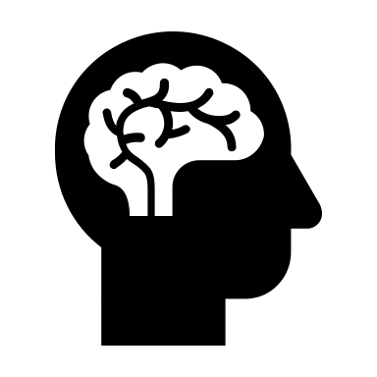

Good for your BRAIN!

Good for RELAXING

Good for your BODY!

This work by T. Westwood is licensed under a Creative Commons Attribution-NonCommercial 4.0 International License.

Goodbye Technology

This work by T. Westwood is licensed under a Creative Commons Attribution-NonCommercial 4.0 International License.

Goodbye technology, I am going

Don’t Believe Everything You See

Big Ideas
- Technologies are tools that extend human capabilities
- Everything we learn helps us develop skills
- Curiosity and wonder lead us to new discoveries about ourselves and the world around us.
BC Curricular Competencies  - Use materials, tools, and technologies in a safe manner in both physical and digital environments.  - Use developmentally appropriate reading, listening, and viewing strategies to make meaning.  - Ask questions, make inferences, and draw conclusions about the content and features of different types of sources. | BC Curricular Content  - Metacognitive strategies | BC Digital Literacy Framework  - The student understands that anyone can publish on the Web, so not all sites are equally trustworthy.  - The student understands that they can go to exciting places online, but needs to follow certain rules to remain safe.

Students will watch a faked video and discuss why it is important to think critically about what they see or read on the internet.

This activity is approximately 50 minutes.

Materials needed:
- Tablet or computer connected to projector.
- Copies of Fake News
- Online Safety Wheel

Prep:
- Pre-search online videos
- House Hippo – Concerned Children’s Advertisers

- Pause and Think Online – Common Sense Education

Activity | Time | Teacher | Learners | Observe/Assess
Engage | 2 min. | - Hey! Let me show you something so adorable I found on YouTube!  Search “house hippo YouTube” and show the video, stopping at 0:46. | Watch and listen | Listens  Participates  Shares ideas
Discuss | 10 min. | - What did you think?  Let the students discuss without you telling them if it was real or not. Then show the ending.  - In the old days, we used to say, “I’ll believe it when I see it, but nowadays, you can only believe what you see in person. People have learned how to use computers to make very real looking photos and videos, like the House Hippo. You have to think about everything you see or read on the internet because anyone can put information on there. Why do you think people put untrue things on the internet?  Responses  - Maybe they are just trying to be funny or maybe they are trying to trick you.  - What if someone made a fake news video that told you the tooth fairy is no longer coming to your house for your teeth and that she wants everyone to mail their teeth to a house in Alaska? So all the kids mail their teeth to Alaska but no one sends back your tooth fairy money! Instead, someone in Alaska is getting all the teeth and putting them under his pillow! Shock and horror.  - What should you have done when you saw this fake news?  - Think about our Online Safety Wheel.  Refer to where you have it posted.  - Tell an adult. Only go to Safe Places. Your grown-ups can help you look for a different, more trustworthy news video. If you can’t find the same news somewhere else, it is probably not true. | Engage in group discussion | Listens  Participates  Shares ideas
Make up your own Fake News | 30 min. | - Let’s have some fun and make our own fakenNews! Do you think you can trick your family?  Brainstorm some fake news together and turn it into some short headlines that students can copy off the board or let students “kidwrite” and scribe afterward.  Unicorn found in Victoria! Talking dog recites alphabet! Kindergarten goes on Rocket Trip!  Using a copy of Fake News and the tooth fairy story, demonstrate how their head and shoulders newscaster goes on the left while their image goes in the box on the right and the headline “Mail Teeth to Tooth Fairy” goes in the gray box on the bottom.  Return to seats or clipboards to complete their news story. | Engage in group discussion  Students illustrate and print their headline | Listens  On task  Does best work  Demonstrates writing development
Recap | 4 min. | - Thumbs up if you did your best work? Best printing? Best drawing? Best colouring?  - What did we learn about what we see and read on the internet?  - Let’s wrap it up with a quick song.  Search “Pause and Think Online” on YouTube. | Reflect on their work time  Engage in group discussion | Thumbs up  Listens  Participates  Shares ideas
In the following weeks, anytime you are on the internet…
- Refer to the Online Safety Wheel.
- Talk aloud about why you think you have found a trustworthy source.

Fake News

This work by T. Westwood is licensed under a Creative Commons Attribution-NonCommercial 4.0 International License.

BREAKING
NEWS

Keeping Private Information Private (3 parts)

Big Ideas
- Technologies are tools that extend human capabilities.
BC Curricular Competencies  - Use materials, tools, and technologies in a safe manner in both physical and digital environments  - Use sources of information and prior knowledge to make meaning.  - Use developmentally appropriate reading, listening, and viewing strategies to make meaning. | BC Curricular Content  - Letter knowledge  - Letter formation  - Practices that promote health and well-being  - Hazards and potentially unsafe situations | BC Digital Literacy Framework  - The student understands the reasons why people use passwords, the benefits of using passwords, and knows strategies for creating and keeping strong, secure passwords.  - The student understands they can go to exciting places online but needs to follow certain rules to remain safe.

This activity is divided into 3 parts.
Part 1: Students will discuss the concept of secrets, good and bad. (15-20 min)
Part 2: Students will create a secret username for themselves. (25 min)
Part 3: Students will learn about passwords and make a password of their own (15-20 min)

Part 1: Secrets

Materials needed:
- New class toy hidden in a bag.
- Computer/digital device connected to digital projector

Activity | Time | Teacher | Learners | Observe/Assess
Engage | 3 min. | - I have a secret. Would you like to know my secret? It’s in this bag. Do you want to guess? First, let’s talk about secrets. What is a secret?  - There are different kinds of secrets. There are good secrets and bad secrets. An example of a good secret is when your mom tells you there’s going to be a surprise birthday party for your brother, and you can’t tell him. You have to keep the party a secret. Or like when you wrap a gift for grandma, and you have to remember not to tell what is in the box, so she is surprised when she opens it. These are good secrets and it’s good to keep good secrets.  - There are also bad secrets that are not good to keep, like when someone hurts you or your feelings and tells you not to tell because they are afraid of getting in trouble. These bad secrets, you should not keep because that person might need help to learn how to be a good person and we always want to help each other be the best we can be.  - Do you think this (in the bag) is a good secret or a bad secret? It’s a good secret, because I know not to keep bad secrets. I’m willing to tell the secret to our special helper (SH). SH, do you want to know the secret now, or wait for the surprise? If I tell you, you have to keep the secret. Can you do that?  - Now 3 guesses from the class. Okay SH, do you remember what the secret is? Let’s show them. Were you surprised? Who likes surprises? Was that a good secret or a bad one? Good, because it made everyone happy. | Engage in group discussion | Listens  Participates  Shares ideas
Turn and talk | 10 min. | - Let’s see if you know which is a good secret and which is a bad secret. Talk to your elbow buddy about it and decide if you tell or keep the secret.  Give time for turn and talk after each scenario and then discuss as a group.  (Add your own examples depending on your group and how long they can sit for discussion).  1. Your sister threw a ball in the house and broke a glass. She asks you not to tell anyone.  2. Grandma says she is knitting a new sweater for mom, but she says it’s a secret and you must not tell.  3.Your little brother has a new toy car and he tells you he got it from a friend at school but don’t tell mom.  4. Your stepdad teaches you and your mom his cell phone number and says you can use it to call him but don’t tell the number to anyone else.  5.Your friend says she wants to make a secret club, but you need a password to join in. Who can tell me what a password is? Password is a secret code that means you can be told the secret. This is a good conversation for talking about inclusion. | Engage in pairs/group discussion | Listens  Participates  Shares ideas
Link to technology | 3 min. | - Have you ever noticed when a grown up goes on the computer or tablet, they usually need to put in a username and a password? Let me show you.  On the projector, make sure you have previously signed out of your computer/device.  - When I turn on my computer, see right here, it asks for my username and password. Why do you think that is?  - Because there are secrets on my computer. What kinds of secrets do you think are in here?  - Your personal information like names, addresses, and phone numbers. Work that I’ve done that I don’t want anyone to accidently change.  - My email conversations that might have my good secrets hidden in them.  - If I keep lots of secrets on my device, should I tell people my password? No, I have to keep my password a secret too! | Engage in group discussion | Listens  Participates  Shares ideas
Recap | 2 min. | - What did we learn about secrets? | Engage in group discussion. | Active listening.  Participates  Shares ideas

Part 2: Usernames

Materials needed:
- Digital device connected to projector
- Card stock cut into 3” x 4” cards
- Illustrated Online Safety Wheel

Activity | Time | Teacher | Learners | Observe/Assess
Engage | 2 min | - Today, we’re going to talk more about secrets and staying safe on the internet. Let’s have a look at our Online Safety Wheel. Who can tell me one of the rules? | Engage in group discussion. | Listens  Participates  Shares ideas
Discuss what a username is and how to create one | 10 min | - Let’s talk about private information. Do you remember when we talked about secrets? What do you remember?  - What do you remember about keeping secrets on the computer?  - Some websites and apps ask you for your name, your age, your address, or your email address. We know we don’t put these things in because we learned it when we were creating the Online Safety Wheel. That’s private information and only grown-ups can decide to put that online for you.  - Sometimes, computers or apps ask you to enter a username. Remember how my computer asked for my username and password because of all the secrets I keep on there for work. In that case, the school gave me my username. Grown-ups might use a real name for a username, but if you can choose your own, you should choose a username that isn’t your real name. A username is like a nickname. Do any of you have a nickname?  - When I was little, my ___ used to call me ____.  Students will share their nicknames.  - Today, let’s all make a secret username, a secret nickname that is just for when we are online.  - Hmmm…let’s see if I can think of a username that I will always remember. I don’t want it to have any personal information in it, so I’m not going to put my birthday in it, or the name of my sports team, or the name of where I live. Hmmm…what can I use? I like tigers and the colour purple maybe I can be PurpleTiger. Lots of people like purple and tigers so it’s not too personal, but it is something I would remember. Now let’s all try. Who has an idea?  As the students share their ideas, talk about how they picked it and whether it is too personal. Then, once they have a good one, write it on a sentence strip for them to copy onto their 3x4 card. | Engage in group discussion  Invent a username | Listens  Participates  Shares ideas
Invent and record a username | 10 min | Give students time to copy their username onto their card and then collect all the cards and record their name and username for your reference. | Copy username onto card | Listens  Participates  Shares ideas
Recap | 2 min | - How do you feel about your secret username? Is it a good one? Remember to keep it a secret.  - What did you learn about usernames today? | Engage in group discussion

Part 3: Passwords

Materials needed:
- Digital device connected to projector
- 3x4 cards you previously used for their usernames
- Enlarged copy of poem, I Made a New Password

Prep:
- Pre-search online video
Story read aloud - Password, Please? by Hahishta Mistry

Optional:
- Enlarged or projected copy of QWERTY Keyboard
- The Password Rap

Activity | Time | Teacher | Learners | Observe/Assess
Engage | 2 min | - Do you remember what we learned about secrets? Who can tell me how we keep our secrets safe when they are on our computer, tablet, or smartphone?  - Do you know any passwords?  - Who wants to tell me their password?  - Should you tell people your password? No, it’s a secret.  - Tell me your password. (Shake your head) You say, “No, it’s private.”  Encourage them all to say, “No, it’s private”.  - Come on, tell me your password, I won’t tell anyone. You can whisper it to me. (Shake your head) | Engage in group discussion | Listens  Participates  Shares ideas
Watch story and discuss | 7 min | - Let’s learn a bit more about passwords. We are going to listen to a story.  Watch the read aloud story, Password, Please? up to 5:48.  FYI – An almirah is an Anglo-Indian word. It is a special cupboard for storing important items and clothing.  - What did this story teach you about passwords? | Watch and respond | Watches  Listens  Listens  Participates  Shares ideas
Invent and record a password | 5 min | - Now here’s something personal that I can keep locked up for you. Show a scrapbook. This one is Bobby’s. Bobby, do you want to make a password, so you are the only one that gets to look or show people what’s inside?  - You are all going to make a password for your scrapbooks, but before we do that, I have a poem to show you. This poem is about making passwords. Let’s read it together.  Read aloud I Made a New Password.  - Uh oh, he forgot his password. I think he made his password too tricky.  - Now 8 characters is a lot to remember when you’re in kindergarten. It’s even tough when you’re older. Let’s try to make a secret password that is 4 or 5 characters long. Your password needs 1 uppercase letter, 1 lower case letter, 1 number, and 1 special character. Here’s a picture of a keyboard to help you choose.  Show QWERTY Keyboard image or similar on your projector. Show them the letter characters and the special characters. Slashes and backslashes cannot be used.  - Print your secret password on your card along with your username.  - Now that you’ve created your username and password, did you let anyone see it?  - We’re going to pretend that I am the computer and you set your username and password by giving it to me.  Glue it into their scrapbooks for your reference.  - Next time you want to see your scrapbook, you need to tell me your username and password. | Participate  Create a password with 4 - 5 characters | Listens  Participates  Shares ideas
Recap | 2 min | - How do you feel about your secret password? Is it a good one? Remember to keep it a secret.  - What did you learn about Passwords today? | Engage in group discussion

In the following weeks…
- Provide an opportunity for each child to tell you their username and password and have a look in their scrapbook.
- Show The Password Rap as a reminder if making new passwords.
- Practice using passwords with school computers.
- If you use any apps where applicable, show how numerical codes, QR codes and fingerprints are like a password.
- If you use an app where you pre-load names (such as EPIC books), use their usernames.

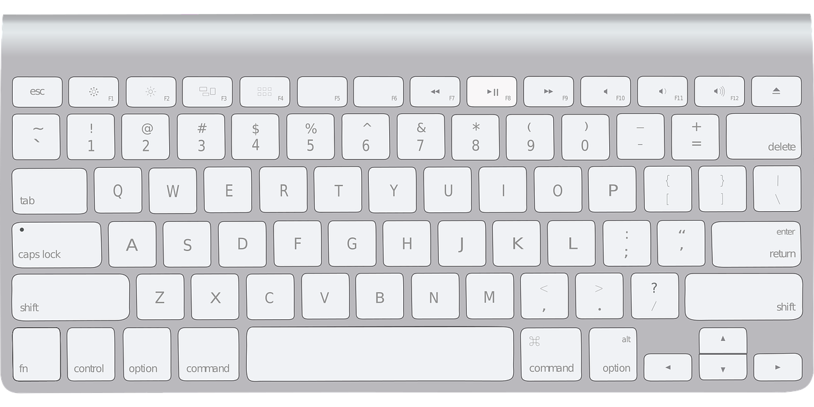
Image by Tanya Ferrera from Pixabay

QWERTY Keyboard

I Made a New Password

Use the following link to Kenn Nesbitt’s Poetry4kids.com for an audio file reading this poem

I Made a New Password

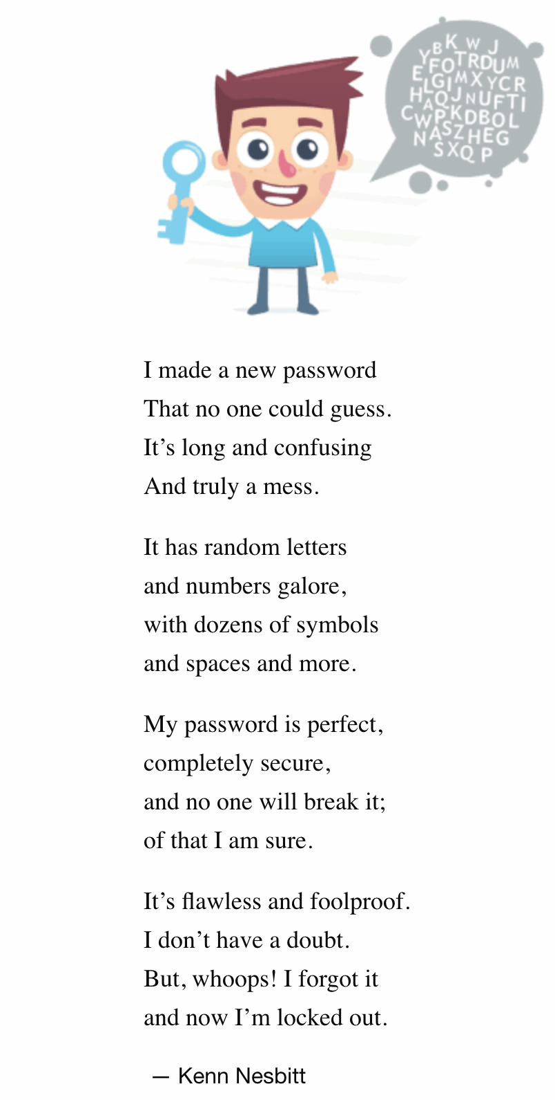

"I Made a New Password" copyright © 2018 Kenn Nesbitt. All Rights Reserved. Reprinted by permission of the author.

Digital Footprints: Protecting Your Private Info (2 Parts)

Big Ideas
- Technologies are tools that extend human capabilities.
BC Curricular Competencies  - Use materials, tools, and technologies in a safe manner in both physical and digital environments. | BC Curricular Content  - Hazards and potentially unsafe situations. | BC Digital Literacy Framework  - The student understands that they can go to exciting places online but needs to follow certain rules to remain safe.  - The student is aware that many websites ask for information that is private and knows how to responsibly handle such requests.

This activity is in 2 parts.
Part 1: Students will learn about their digital footprint and make a footprint sign. (35-40 min)
Part 2: Students will use their footprint tool in a quiz as well as keep as a reminder for at home. (20 min)

This activity is approximately 50 minutes.

Part 1: Introduction and Tool

Materials needed:
- Picture book Footprints in the Snow by Mei Matsuoka
- Digital device connected to projector
- Print off master copies for Digital Footprints OK and Digital Footprints NO, and prep as noted below.
- Red and green paper
- Popsicle sticks
- Glue

Prep:
- Copy Digital Footprints OK onto green paper and Digital Footprints NO onto red (or print both on white if you prefer to have students colour their own).
- Pre-search online video,
Follow the Digital Trail – Common Sense Education

Activity | Time | Teacher | Learners | Observe/Assess
Engage | 15 min. | Introduce the story, Footprints in the Snow by Mei Matsuoka.  - This is Wolf. What do you think this story is about?  Read or show the story.  - Is Wolf a good guy or a bad guy?  - What was Wolf following?  - In the end, Wolf finds real footprints in the snow. Do you think he will eat whoever he finds at the end?  - Have you ever noticed when you have left your footprints behind?  - Where have you left them? Snow, sand, mud? | Engage in group discussion | Listens  Participates  Shares ideas
View and Discuss | 5 min. | - Did you know you can also leave footprints on your computer, tablet, or smartphone? And just like in the story, someone could use your footprints to find you. Let’s watch a little video to get some ideas.  Show the video, Follow the Digital Trail.  - What kinds of things did the characters say about footprints?  - What kind of information did they say was okay to share online?  Hobbies and favourite things.  - What was not okay?  Name, address, phone number, age & birthday, and your school.  - Private information can be used to find you so it’s important to keep that information private. Most of the people online are good people, and some people just want to know everything about you so they can sell you things, but some are big bad wolves. They probably don’t want to eat you, but they may still want to find the real you, so it’s best not to leave those footprints. No one wants to be that poor ducky in the story! | Engage in group discussion  Watching and listening  Engage in group discussion  Engage in group discussion | Listens  Participates  Shares ideas
Instructions to make a tool | 15 min. | - Let’s make a tool to help us remember how to keep private information out of our footprint.  Show them both colours of footprint.  - Red means stop, or NO, don’t do it. What information do you think is on the red footprint?  Let them guess, then flip it over and read the other side with them.  - Green means Go or OK. But remember, you should still ask one of your grown-ups first. What information do you think is on the green footprint?  Let them guess, then flip it over and read the other side with them.  Demonstrate how to cut out and glue footprints back-to-back with a popsicle stick protruding from the bottom like a stop sign.  Give students each a green and red footprint.  Allow students to make their tool.  Allow to dry. | Watch demo and make their own sign/tool | Listens  Participates  Shares ideas
Recap | 2 min. | - How did your tool work out? Thumbs up if you’re happy with it.  - What did we learn about digital footprints? | Engage in group discussion | Listens  Participates  Shares ideas

Part 2: Quiz

Materials needed:
- Completed and dry footprint tools
- Digital device connected to projector

Prep:
- Pre-search online videos
1. Follow the Digital Trail – Common Sense Education

2. Pause and Think Online – Common Sense Education

Activity | Time | Teacher | Learners | Observe/Assess
Engage | 3 min. | - Who can tell me what you remember about digital footprints?  - Let’s look at this video again.  Show Follow the Digital Trail | Engage in group discussion | Listens  Participates  Shares ideas
Review footprint tool | 2 min. | - Let’s take a quick look at our footprint tool. What does the red side mean? What does the green side mean? | Engage in group discussion | Listens  Participates  Shares ideas
Quiz | 10 min. | - I am going to give you a scenario of when you might want to put things on the internet. Hold up the red side if it is private and should never be shared. Hold up the green side if it is personal and can be shared if your grown-up says it’s okay.  Discuss each scenario in turn.  Examples:  1. Your cousin is showing you a fun website and says you can be a member too. He needs to enter your name and birthday. Do you say OK or NO?  2. You are playing a video game that lets you chat with other players. One online friend thinks you have a lot in common and says he can come to your house if you put your address in. Do you say OK or NO?  3. You and a friend are playing with her mom’s phone. She suggests you take a selfie together and send it to another friend. Do you say OK or NO? (Make sure they understand the part about asking their own grown up).  4. You and a friend are having a video visit on Messenger Kids. You want to show her a picture that you painted that day. Is it OK to show her?  5. You found a funny picture of your little brother, naked in the bathtub. Is it OK to show it to your Messenger Kids friend? | Listen and show either the red side or green side in response to scenarios  Engage in group discussion | Listens  Participates  Listens  Participates  Shares ideas
Recap | 5 min. | - You all did a good job thinking carefully about the information you put online. Thumbs up if you think this tool will help you pause and think online. Do you want to take the tool home to help you remember?  - Where do you think would be a good spot to keep it?  - Do you think you can explain it to your family?  - What will you say?  - Let’s wrap it up with another look at this video.  Show Pause and Think Online | Engage in group  discussion | Listens  Participates  Shares ideas

More:
- You might want to laminate the footprint tool to send home. In your communication home, explain the tool and suggest they refer to it when going online with their child.

In the following weeks…
- Refer to the footprints you leave when you are modelling online activity.

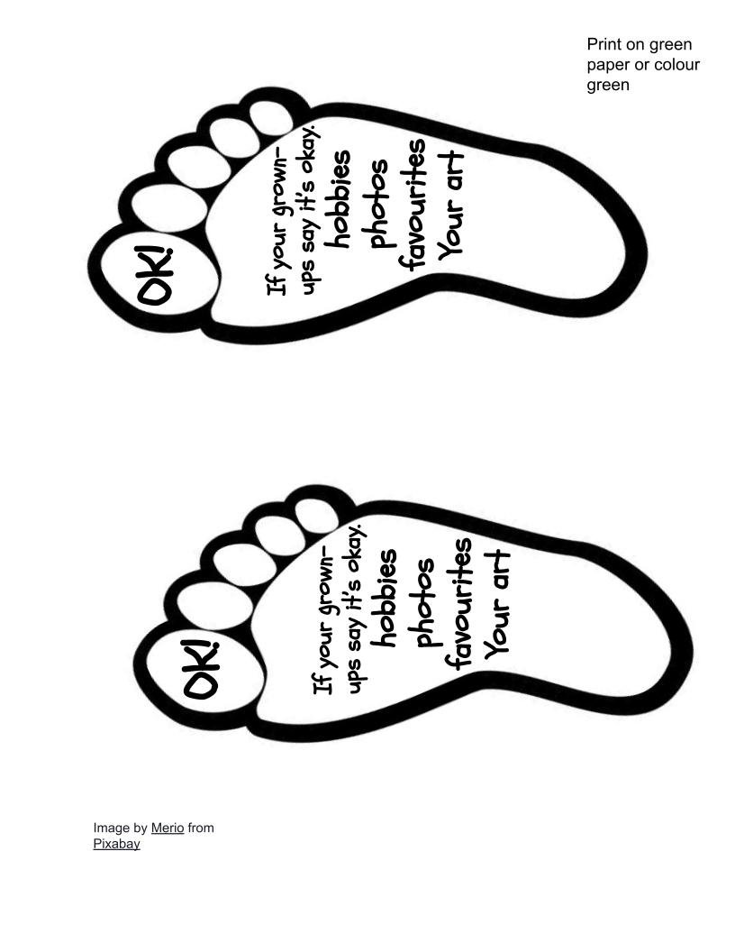
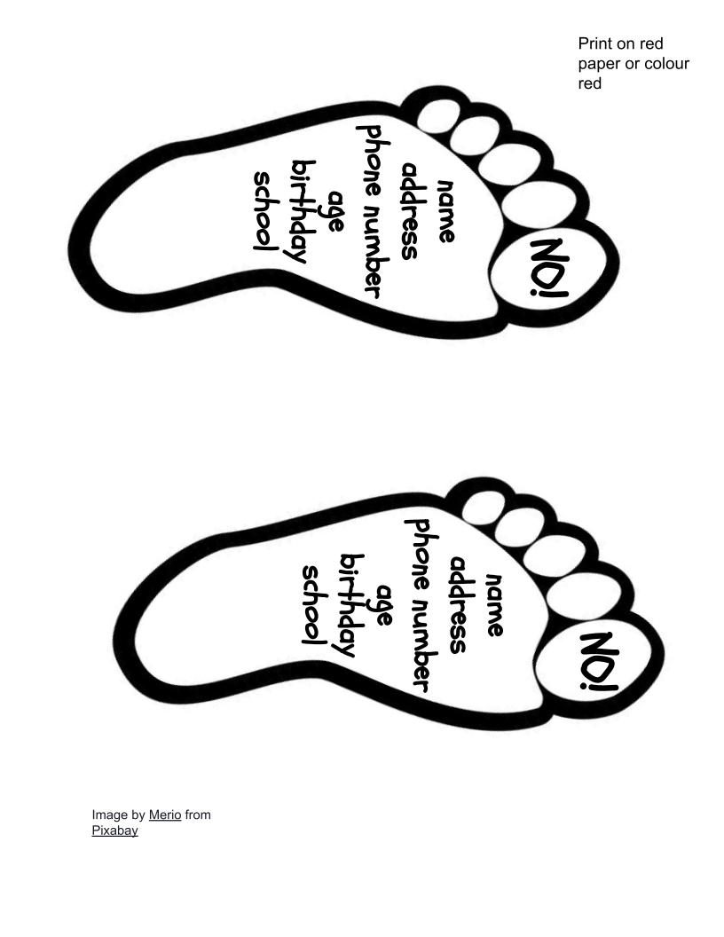
Digital Footprints NO

Digital Footprints OK

Email

Big Ideas
- Technologies are tools that extend human capabilities.
- Through listening and speaking, we connect with others and share our world.
- Our communities are diverse and made of individuals who have a lot in common.
- Stories and traditions about ourselves and our families reflect who we are and where we are from.
BC Curricular Competencies  - Generate ideas from their experiences and interests.  - Add to others’ ideas.  - Choose an idea to pursue.  - Decide on how and with whom to share their product.  - Use materials, tools, and technologies in a safe manner in both physical and digital environments.  - Recognize the importance of positive relationships in their lives.  - Work respectfully and constructively with others to achieve common goals.  - Exchange ideas and perspectives to build shared understanding.  - Acknowledge different perspectives on people, places, issues, or events in their lives. | BC Curricular Content  - Reading strategies  - Oral language strategies  - Writing processes  - Language features, structures, and conventions.  - Ways in which individuals and families differ and are the same. | BC Digital Literacy Framework  - The student understands that they can go to exciting places online but needs to follow certain rules to remain safe.  - The student uses email to communicate with real people within their school, family, and community.  - The student understands how the ability for people to communicate online can unite a community.  - The student communicates effectively by email, takes into account the purpose and audience of their message, and the tone they want to convey.

Students learn about email and work together to compose an email to a pre-arranged recipient. They will identify ideas to share and choose which are appropriate for their audience.

Materials needed:
- Digital device connected to projector

Prep:
- Arrange with principal or a buddy class to communicate via email.
- Decide for yourself, or ask your administrator, if you should use your email address or create a separate email address for the class (preferred).

Activity | Time | Teacher | Learners | Observe/Assess
Engage | 5 min. | - Who has heard of email before?  - What can you tell us about it?  - What do people use it for?  - How would you like to help me email someone? | Engage in group discussion | Listens  Participates  Shares ideas
Demonstrate creating an email on the projector | 5 min. | - Should we email someone we don’t know? No, let’s email someone we trust. How about -------?  Open the compose pane in email.  - I know the email address of this person. It is ________. It goes here in the To line. You can tell it is an email address because it has this @ symbol in it. (If your email manager usually autofills your contacts, you may need to explain this)  - Now what should we talk about?  Compose email together, including salutation, body, and closing.  Remind them about what is appropriate, sharing private vs personal info, being kind online.  - Do we want to talk about things we have learned about?  - Do we want to talk about Bobby’s underwear?  - Do we want to talk about our favourite things to play?  - Do we want to tell them their hair looked yucky today?  If you are using a tablet or smartphone, you can ask if they would like to add a photo.  - Who would like to be in the photo? | Watch and  engage in group discussion  Watch and  engage in group discussion | Listens  Participates  Shares ideas  Listens  Participates  Shares ideas
Recap | 2 min. | - Thumbs up if you think we wrote a good email. Let’s read it together.  Read through email together.  - Did we make it interesting?  - Were we kind?  - Did we keep our private information private? | Engage in group discussion | Listens  Participates  Shares ideas

In the following weeks…
- Read and reply to emails received. Continue correspondence.
- Try communicating with an international buddy class, students’ parents, or an expert in something you are studying.

Coding (3 parts)

Big Ideas
- Skills can be developed through play.
- Technologies are tools that extend human capabilities.
- Effective collaboration relies on clear, respectful communication
- Everything we learn helps us to develop skills.
BC Curricular Competencies  - Use trial and error to make changes, solve problems, or incorporate new ideas from self or others.  - Use materials, tools, and technologies in a safe manner in both physical and digital environments.  - Develop their skills and add new ones through play and collaborative work.  - Work respectfully and constructively with others to achieve common goals.  - Use developmentally appropriate reading, listening, and viewing strategies to make meaning.  - Use technology to explore mathematics.  - Develop and use multiple strategies to engage in problem solving. | BC Curricular Content  - Number concepts to 10  - Repeating patterns with two or three elements | BC Digital Literacy Framework  - The student understands that computer programming algorithms are sets of instructions that tell computers what to do

This activity is divided into 3 parts.

Part 1: Students will discuss how a step-by-step hand-washing poster gives instructions to follow in a language they understand. (15 min)

Part 2: Students will role play programmer and robot as they give instructions to a classmate using simple directional signs. (30 min)

Part 3: Students will learn to code a robotic mouse (60 min)

Part 1: How to Wash Your Hands

Materials needed:
- Hand washing steps poster. If you don’t already have one, there are many available online including Handwashing 101 from cbckids.ca.
Prep: (optional)
- Print your poster

Activity | Time | Teacher | Learners | Observe/Assess
Engage | 3 min. | - Who here has ever washed their hands? Oh, that looks like everybody. Do you think you all wash your hands the same way? Tell me what you do? | Engage in group discussion | Listens  Participates  Shares ideas
Follow the hand washing instructions | 5 min. | - Let’s say that we all need to wash our hands the same way. Some scientists have done some experimenting and decided that this poster shows the best way to wash hands. It has steps to follow. Let’s all pretend to follow these instructions.  - What’s first?  - What’s next?  Go through the steps together. Point out the instructions one by one.  - Did you follow all the instructions just the way they were lined up?  - Do you think you would get the job done properly if we mixed up the instructions?  - What if we did this one and then this one and then this one? Would that work?  Mix the instructions up in a way that definitely wouldn’t work. | Pretend to wash hands | Listens  Participates  Shares ideas
Link to technology | 3 min. | - You did an excellent job. It was almost like you were a computer or a robot, and I was telling you the code for doing the job properly. | Engage in group discussion | Listens  Participates  Shares ideas
Recap | 2 min. | - What did we learn about following instructions? You have to do them in order. They help you do things the right way. | Engage in group discussion | Listens  Participates  Shares ideas

Part 2: My Robot Friend

Materials needed:
- Traffic cones or some type of obstacles
- A flag or signal, such as a bell or buzzer, to mark the finishing spot
- Tape (optional)
- Enough copies of Coding Game Cards to provide a set of 3 to each pair/team.

Prep:
- Print and cut Coding Game Cards
- In a large space, set up enough starting spots for several students, some obstacles, and a flag or signal.
- Use tape to mark out a grid in a large space (optional)

Note: If you are in the classroom, you can use the furniture as obstacles.
Activity | Time | Teacher | Learners | Observe/Assess
Engage | 1 min. | - Today, we’re going to pretend to be robots! You need a partner.  Help arrange partners. | Engage in group discussion | Listens  Participates  Shares ideas
Game instructions | 5 min. | - In this game, we will be taking turns. Decide who will be partner A and partner B.  - For the first round of the game, partner A will be the programmer and partner B will be the robot. A programmer is the one who creates the code that tells the robots what to do. The code is the instructions. Remember when we followed the picture instructions to wash our hands. This time we have different picture instructions.  Show the set of 3 Coding Game Cards  - These are the only instructions for today. The straight arrow means take one small step forward (or one grid step). This arrow means turn your body to the right. You don’t take a step for this one. Just turn your whole body on the spot. This arrow means turn left on the spot. Who can pretend to be my robot for a moment?  Choose a volunteer.  - If I show you this piece of code, show me what you will do.  - How big a step should the robot use? Just a normal step.  Demonstrate all 3 codes with the volunteer.  - Robots, are you ready to do what your programmer’s code tells you?  - Do exactly what they show you, even if you know it is the wrong way. The programmer has to fix their own mistakes so if they make a mistake or change their mind, you may have to go start again at the beginning.  - Programmers, your job is to get your robot over to the flag without bumping into the obstacles. You will need to use the code to get your robot to go around them. It might be tricky at the start as you figure out how your robot and the codes work, but don’t worry. It gets easier each time you try. Remember your growth mindset. And everyone, this is not a race! Take your time and be careful. | Listen  Ask for clarification  Volunteer follows directions  Listen to instructions | Watches and listens
Play | 20 min. | Stagger their start times and spots so each pair has some space. Monitor their progress.  Switch partners after a while or after they reach the flag or signal. | Play | Has fun.  Makes progress.  Follows the rules.
Recap | 2 min. | - What helped you be a successful programmer?  - What did you learn about being a programmer today? | Engage in group discussion

Part 3: Programmable Robots

Materials needed:
- Digital coding toy such as a Bee-Bot Robot or a Code & Go Robot Mouse
- Either a mat or materials to build a grid or course.
Prep:
- Make sure your robot is charged or batteries are functioning.
- Set up mat on hard surface or set up course using materials at hand.
If you haven’t purchased a robot yet, internet search “coding robot for kids”. There are many to choose from.
Optional:
- Use additional play mats purchased for the toy.

Activity | Time | Teacher | Learners | Observe/Assess
Engage | 10 min. | Set up the play space and robot as a provocation for a small group during play or centre time. Set a limit to the number of players. Let them play. Resist getting involved. Monitor and intervene when necessary for social learning. If turn-taking becomes an issue, you may wish to set a timer or define a turn. | Explore, discuss, suggest, take turns | Positively interacts  Participates  Shares ideas  Demonstrates patience
Reflect | 2 min. | Ask everyone in that particular group of players,  - What’s happening here?  - What are you trying to do?  - How does it work?  - Is it easy?  - What do the buttons do?  - Okay, time to let the next group have a go.  Repeat with other groups until everyone has had a quick turn with the buttons. Regroup after clean-up time. | Engage in group discussion | Listens  Participates  Shares ideas
Recap | 3 min. | - What did you think about the new toy?  - Did the robot always do what you were expecting?  - Think about our game with the programmer and the robot that we played last day. Did you notice any similarities?  - Did you notice you were programming code into the robot?  - The buttons represent blocks of code and when you put a bunch together, what was happening?  - Would the robot do that without the programmer putting the code in? Nope, the robot only knows how to follow your directions. You have to think, think, think about what codes to punch in before you press go. | Engage in group discussion

In the following weeks…
- Provide an opportunity to play My Robot Friend again. Consider changing the goal or changing the course.
- Provide many opportunities for children to play with the programmable robot. Encourage them to make a goal for where they want the robot to end up.
- Encourage the programming team to use multiple sets of the Reproducible: Coding Game Cards to plan their program.

Coding Game Cards

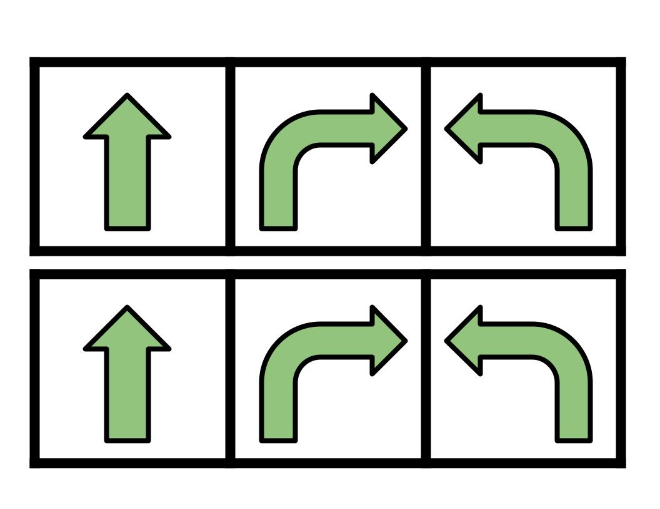
This work by T. Westwood is licensed under a Creative Commons Attribution-NonCommercial 4.0 International License.

